Assignment 4 Report

Linked list output

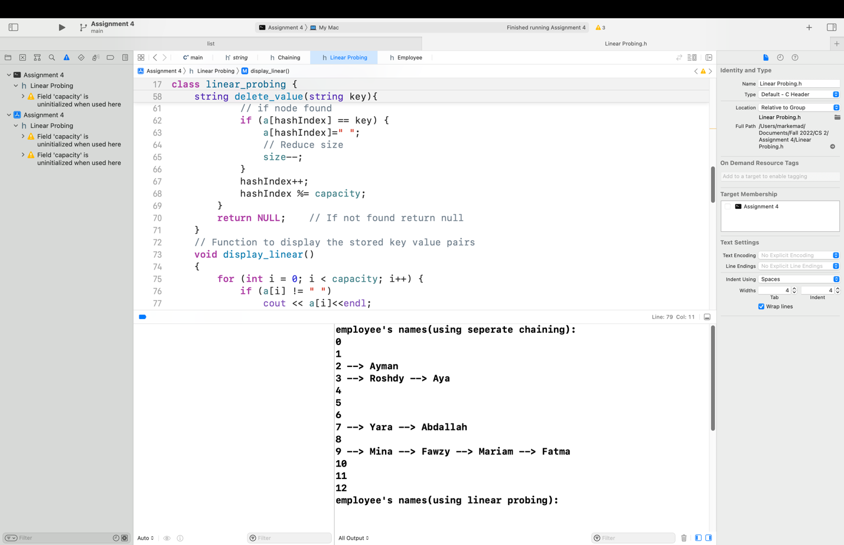

Linear probing output(dynamic array)

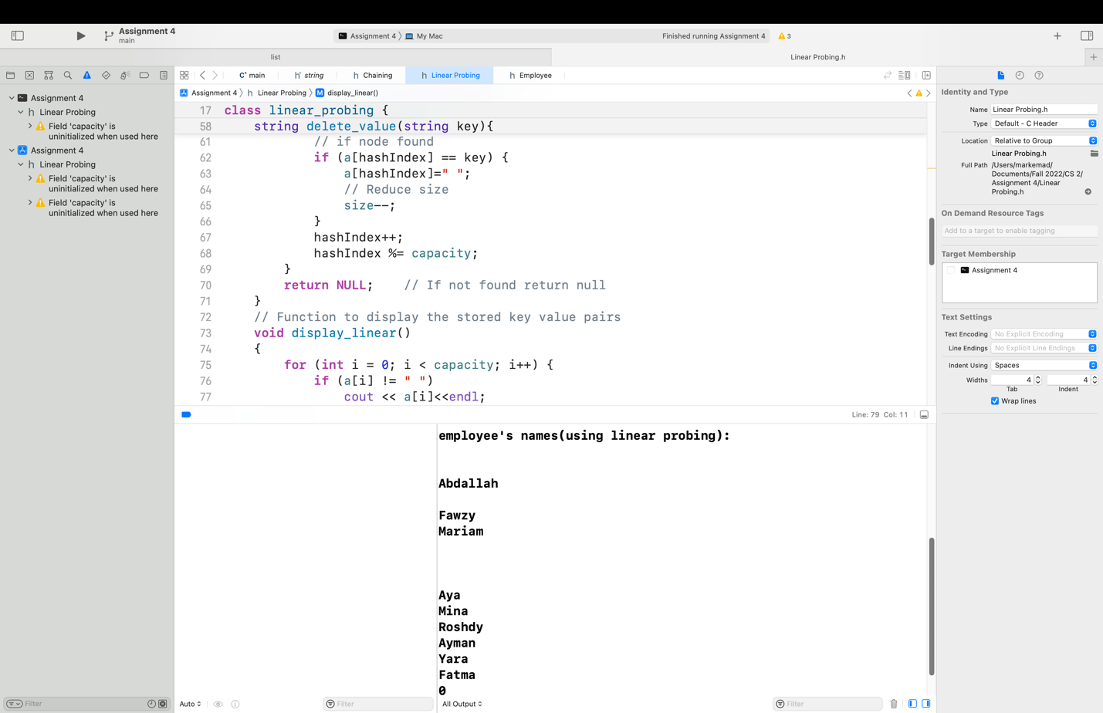

I see that the linked list(separate chaining method) is more efficient as it can use less space than the other method saving more memory.

Hash functions:-

Linked list: it enters a loop till the end of the string and add to the sum then we do the sum modulus the storage of the array and that is the index of the element. It creates linked list every time it sees a collision in an array of size given in the main.

Dynamic array: it loops on every character in the string and add it to the variable “hash” and get the index from hash modulus capacity. That is the only function that worked with me showing all the names in the table.

I used as reference geeksforgeeks.com and an example from stackoverflow.com.